**ASSIGNMENT-2**

**PORTFOLIO WEBSITE**



**Name:** Nisha Dhanwani

**Student ID:** 300773598

**Course:** COMP229-062

**Submitted to:** Prof. Carmen Branje

**Date:** 05/04/2014

Table of Contents

1. **Description3**
2. **Navbar3**
3. **Colors4**
4. **Typography4-5**
5. **Wireframes5-10**
6. **Branding**11-13

# Description

This is a portfolio website that consists of 5 html pages namely; Home page, About Me page, Projects page, Services page, and Contact page. It also has a link to the GitHuB repository where all the html, css and javascript files are on the web at a single place. The website home page describes about me and in brief about the work done by me. On button click it navigates to the projects page where details about the projects done are displayed. The About me page gives more detailed information about me and my skills. Services page enlists the services that are offered by me with their description. The Contact page has a keep connected section that links to all the social websites which I am currently active with and some other contact information.

# NavBar



Displays the home page on click.

Displays the contact page on click.

Displays the projects page on click.

Displays the services page on click.

Displays the about me page on click.

Displays the business contact page on click.

# Colours

|  |
| --- |
| Hexadecimal Values |
| #C30 |
| #900 |
| #C60 |
| #2F1700 |
| #930 |
| #630 |
| #592D00 |
| #FFEA6F |
| #2a2a2a |

# Typography

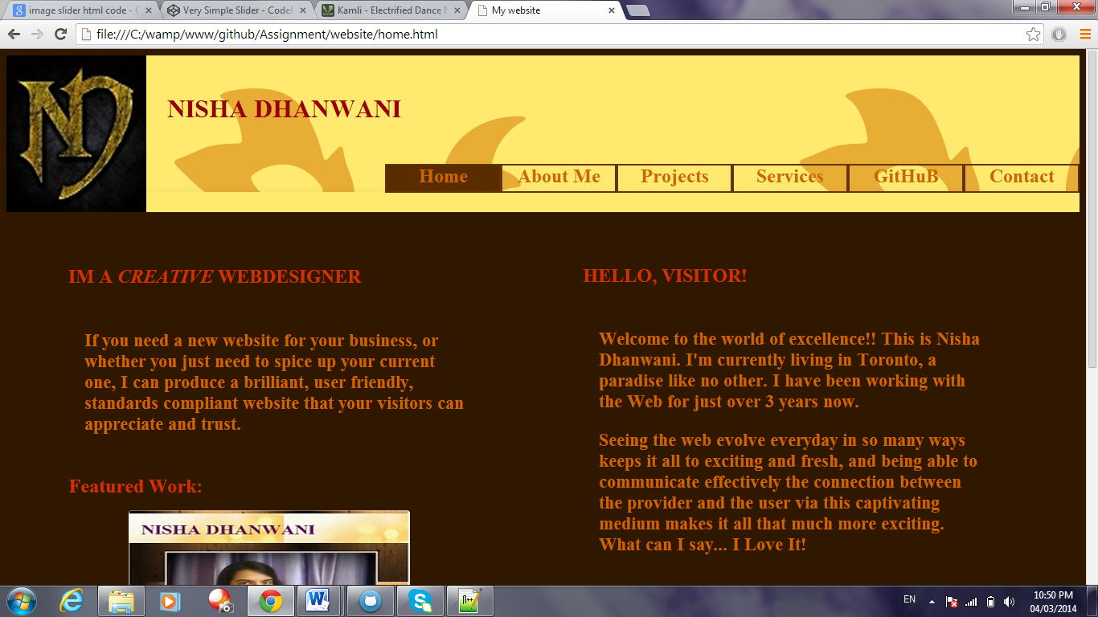

|  |  |  |
| --- | --- | --- |
| Tag | Size | Color Code |
| Name | 32 px | #900 |
| Headings | 24px | #C30 |
| Paragraphs | 20px | #C60 |
| NavBar | 24px | #C60 |

# Wireframes

Navbar

1. **Home Page**

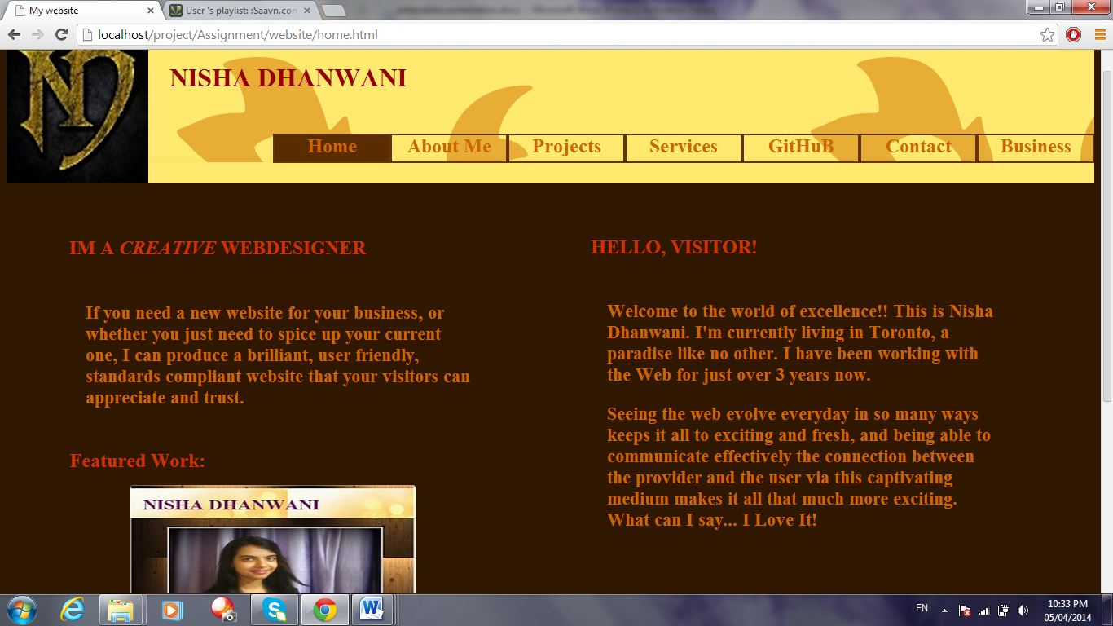

Featured work slider

Description

Name

Logo

1. **About Me Page**



Profile picture

Detailed information about me

1. **Projects Page**

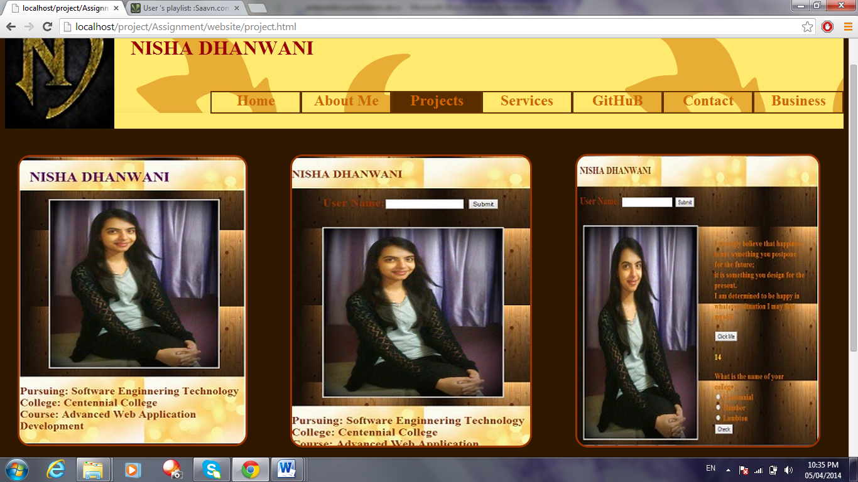

Displays the recent projects done by me

1. **Services Page**

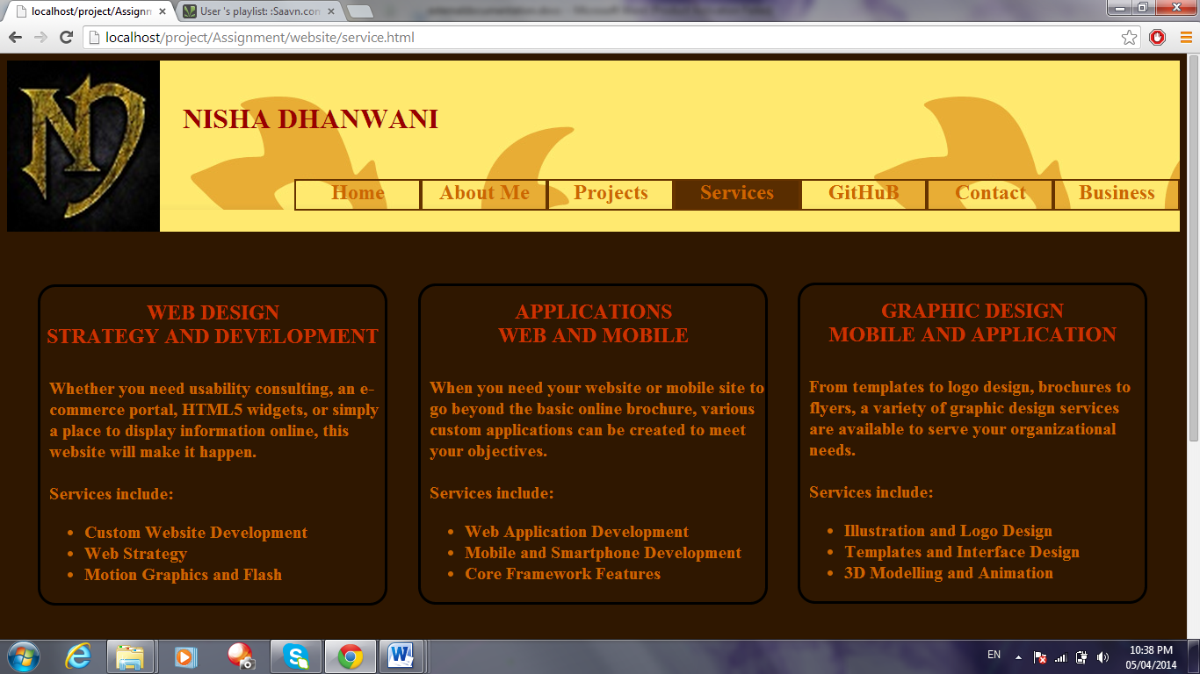

Shows the services offered

1. **Contact Page**

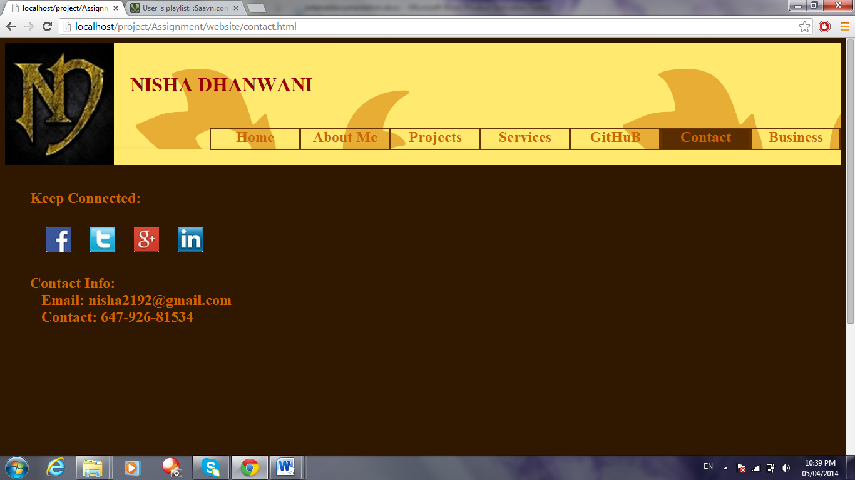

Connects to my profile of all active social sites

Contact Information

1. **Business Contacts Page**

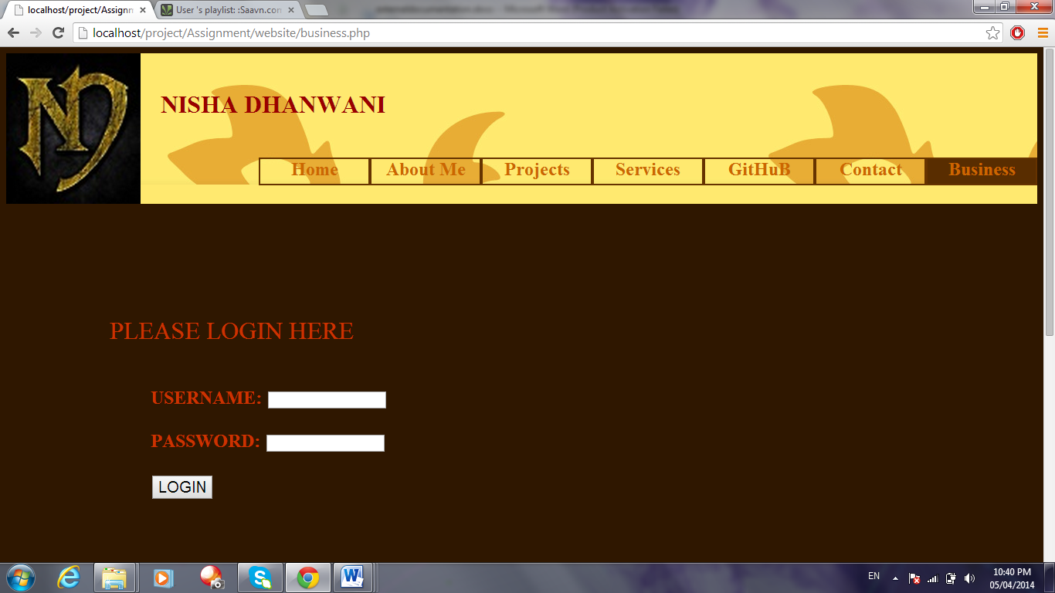

Login form that validates the user

# Branding

